Studio Practice - Assessment task 04 – Studio Project

Weekly Journal

Student Name | Joseph Myers
Project Title | Space Conquest!
Date Started | 24/11/2013
Date Finished | 11/08/13

Week 01
Weekly Progress Report | In the first week I gathered assets to use in my game. This required going to google and searching for free 2D sprites I could use freely (or under CC).  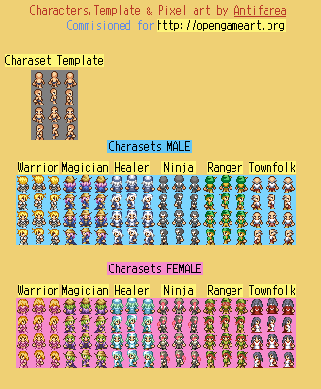The sprite sheet used for player characters.  I also tried to explore Unity as an option. This eventually didn't pan out, however I did start to make a brief for a Unity-made version of my game. This was, however, scrapped shortly after I made my decision not to use Unity.
Reflection | Upon reflection I find that this is a good start to my project. Gathering the needed materials first and exploring the different opportunities allowed me to not feel as restricted as I originally thought.
Actions | As stated above, I gathered assets to use for my game. I went to the website opengameart.org for most of my assets as it included everything from 2d sprites for characters, to character sheets, to music. This allowed a fair amount of freedom when it came to planning the story and setting for my game.
Resource  Bibliography | Opengameart.org – Assets (sprites, music)

Week 02
Weekly Progress Report | In the second week I began editing assets for use in the game and began coding the main menu. For editing, this meant splitting up sprite sheets so that they would be usable. As sprite sheets, they wouldn't work too well due to limitations of Visual Studio. For the main menu I designed it to be navigated via the keyboard to select different options, such as start the game, exit the game, etc., and also added in a basic setup for selecting the ship color and the character. This basic functionality would allow me to eventually move on to the main game and begin adding in basic functionality there. By the end of the week I had finished editing the assets I had, started to code the intro sequence and ship movement, and also began adding in various variables and components for use at a later point.  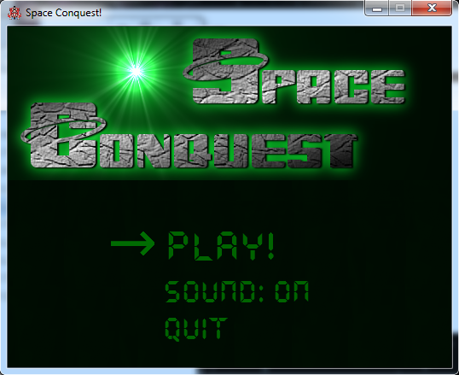Main Menu
Reflection | For this week, I'd say I continued my brisk pace. As I began to actually start coding in Visual Studio, its limitations became more known to me and this allowed me to plan ahead as I went. This will help to keep my current pace, and allow for more room to add things in that I had not originally considered.
Actions | Editing the assets required the use of GIMP to cut them up and save them appropriately for use. In Visual Studio, I began making the first form, the main menu, and adding basic functionality in order to allow myself to begin testing the game and move on to coding the main component of the game without fleshing out all the options available in the main menu. During this week I required the use of various websites in order to find out ways of coding certain things I required, like ship movement, or how certain things work, such as how form “hierarchy” works in Visual Studio.
Resource  Bibliography | msdn.microsoft.com – Visual Studio and C# tutorials and information  stackoverflow.com – Visual Studio and C# “tutorials” (Q and A site for programming)  dotnetperls.com - C# tutorials

Week 03
Weekly Progress Report | During this week I began creating various forms, along with variables, that would be required for future use. I also continued working on the ship movement code, adding in form transitions to allow moving to another “section” of space. This new section of space would have different things that could happen based on random chance. This meant that either the planet appears (to land on and explore), or enemies appear instead. The timers during the intro sequence required tweaking for timing, along with various other minor tweaks for the intro text. By the end of the week I had managed to create a planet form so that the player could land the spaceship, move around as the character, and then return to the space form.  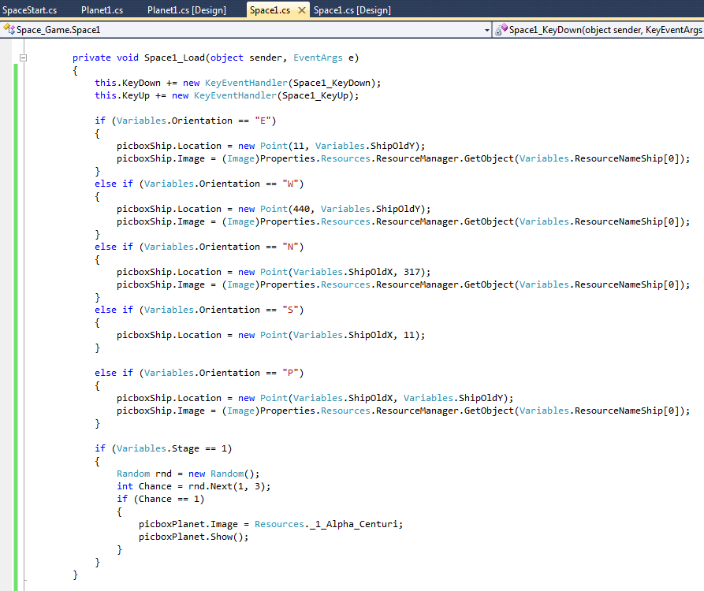Form transition code and variable chance for planet to appear or not.
Reflection | Because of my current pace, the game was beginning to take shape. I could successfully start the game and get to the point of moving around on the planet. While there was no combat or anything else, aside from movement, I still consider this a good start for the third week.
Actions | During this time I realised the necessity of a large amount of picture boxes that would arise later down the line. This lead me to searching out alternatives, such as the “draw” function. However, as this was a completely new function to me the task of taking on an entirely new function and still trying to maintain a good pace meant that I chose against it. While it did have its advantages, it also had some slight disadvantages which also weighed in for my decision.
Resource  Bibliography | msdn.microsoft.com – Visual Studio and C# tutorials and information  stackoverflow.com – Visual Studio and C# “tutorials” (Q and A site for programming)  dotnetperls.com - C# tutorials

Week 04
Weekly Progress Report | As I had managed to get movement working last week, this week I began exploring different options for combat. This meant researching different games and finding out how their combat system worked so I could use them as inspiration or a basis. This also meant gathering more assets to use. By the end of the week I had begun coding planning and coding space and planet combat. I had also began coding for a possible sprite animation.  The monday of next week was also the project milestone presentation #1.  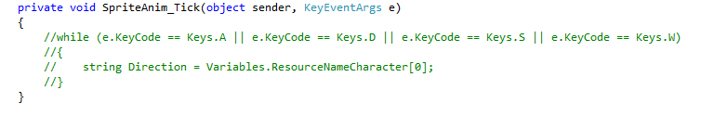Possible animation code (commented out while it wasn't working).
Reflection | My project was beginning to have more to it now as I had began adding in more than just movement, that of combat. While it is still in the early stages, the way I decided to do planet combat seems like it will be relatively easy and straight forward to do, while hopefully still being fun for the player. As for the sprite animation, I am less optimistic as changing the image in the picture box via a timer turns out to be more complex than I initially thought it would be, however this probably just means I will need to find a better, alternate way of doing it than I had thought.
Actions | Since coding in a sprite animation wasn't working as I had intended, I had to look up on various websites how I could accomplish it.
Resource  Bibliography | opengameart.org – Assets (sprites)  msdn.microsoft.com – Visual Studio and C# tutorials and information  stackoverflow.com – Visual Studio and C# “tutorials” (Q and A site for programming)  dotnetperls.com - C# tutorials  en.wikipedia.org – Researching different combat systems in games

Week 05
Weekly Progress Report | Began designing a options form that could be accessed in game. This would have options to resume game, save, turn the sound on or off, and exit the game.  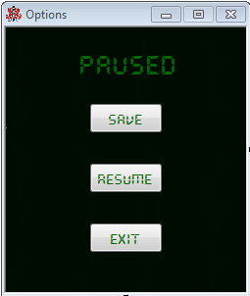Options menu
Reflection | Finding out a way to save the variables and allow them to be loaded up again proved far easier than I had originally envisioned. After looking up how to access, edit, and save external files, I managed to begin coding save and load functions.
Actions | In order to find out how to make a save function, I had to go to various websites in order to find out how to access, edit, and save external files.
Resource  Bibliography | msdn.microsoft.com – Visual Studio and C# tutorials and information  stackoverflow.com – Visual Studio and C# “tutorials” (Q and A site for programming)

Week 06
Weekly Progress Report | For week 6 I began coding in asteroids, having them be a part of the random chance to appear on the space form. I also began to program to move around randomly. With issues arising from that, I had to begin looking into “threads” and “multiple threading”. I also began adding in the death/game over screen and made it possible for the player to “die” by crashing into asteroids.  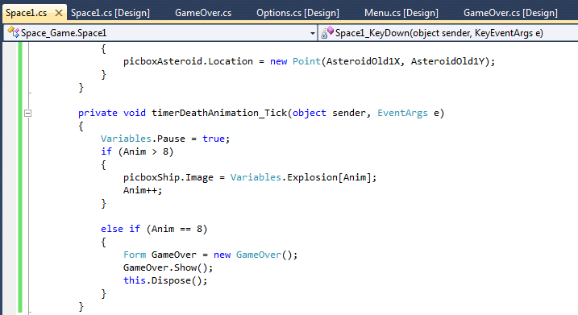Death animation code
Reflection | With the issue of “threading” coming in to play, this slowed my pace somewhat. I had to research on various websites how threading worked and how I could utilise it in my project. Initially this seemed a bit daunting as it was something completely different to what I had done in the past, however I eventually managed to grasp the concept and get at least a basic understanding of it to begin putting it to use in my project.
Actions | To research “threading” I visited various sites such as msdn.microsoft.com and stackoverflow.com.
Resource  Bibliography | msdn.microsoft.com – Visual Studio and C# tutorials and information  stackoverflow.com – Visual Studio and C# “tutorials” (Q and A site for programming)  dotnetperls.com - C# tutorials

TERM BREAK Week 07
Weekly Progress Report | To start the term break off, this week I added in a restart button to the game over screen and pause menu. I also attempted to troubleshoot the on-death animation as it wasn't working. The main menu (and options menu) was also redesigned as I needed another button for “loading”. I continued coding planet combat, even adding in some temporary enemies to test it. With this, I began adding variables for the player's health, dodge chance, attack damage, while also doing the same for enemies. I also added in code to load a game on the first space form and began coding ship shooting (for the combat).  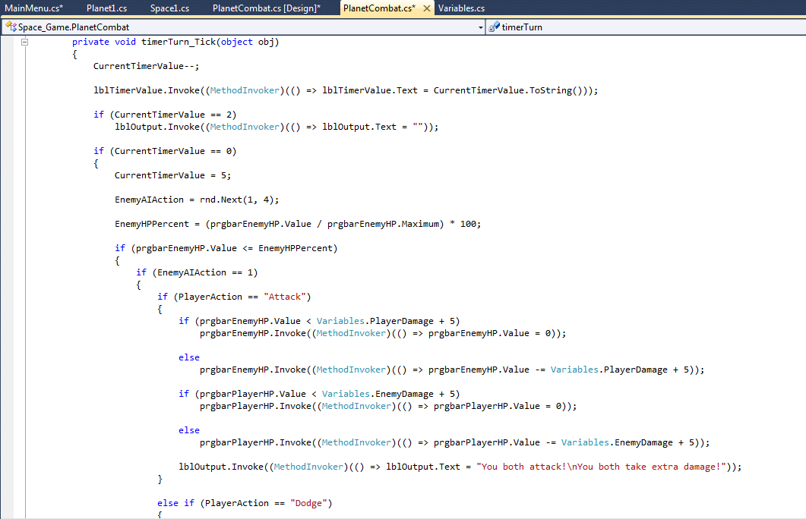Planet combat code
Reflection | I consider this a good start to the term break. After being slowed down learning about “threading”, I managed to get a fair bit done during the first week of the term break. Being able to properly test the new planet combat helped as it meant I was on to the more “fun” parts of making my game.
Actions | Adding in a restart button to the options menu and game over screen meant finding out how to dispose of all forms, except the main menu one, otherwise the game would close as the main menu form is the first one open and therefore the last one to close. This meant I had to go to stackoverflow.com and msdn.microsoft.com to find a way of easily disposing the forms that needed to be disposed.
Resource  Bibliography | msdn.microsoft.com – Visual Studio and C# tutorials and information  stackoverflow.com – Visual Studio and C# “tutorials” (Q and A site for programming)

TERM BREAK Week 08
Weekly Progress Report | To start the week off, I decided to add in enemy scaling values, meaning I could reach the end screen of the game with a basic play-through. With that, I could add in an end screen form that only includes text for now. Returning to the planet combat, it needed a lot of work as the timers used weren't always firing properly. I also looked back to my space shooting mechanic, however issues arose with that so I have to devise an alternative, such as stealth. I also looked at the sprite animation for planet movement. I managed to get the player's character animating as he walks, but it is very buggy and eventually stops working after a certain point. After looking into the death animation again, I managed to get that working too, successfully making the ship animate through a death/blowing up sequence and then loading the death/game over screen. Aside from the previously mentioned issues, the main menu also has a bug, wherein pressing space bar returns the screen to ship selection during character selection.  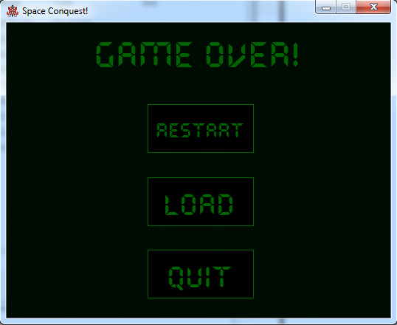Game over screen
Reflection | Despite having issues and bugs arise, I feel the accomplishments gained during this week outweigh them. Having the space combat not turn out well may be a good thing for myself personally, as I much prefer stealth as a gameplay mechanic.
Actions | Both the player's character animation and ship death animation required looking up tutorials and help online in order to get them working.
Resource  Bibliography | msdn.microsoft.com – Visual Studio and C# tutorials and information  stackoverflow.com – Visual Studio and C# “tutorials” (Q and A site for programming)  dotnetperls.com - C# tutorials

Week 09
Weekly Progress Report | During this week I began adding in different classes to choose from. These included: Ninja, Warrior, Priest, Magician, and Ranger. They would each have a different skill based on their class and also different stats to start with. With these additions, I began adding in a class description form that shows up when selecting characters, giving a brief overview of the one the player is about to select. By the end of the week I had some of the special abilities working, however I also had to start researching different ways for the special abilities to work so that they weren't just spammable. During this week I also used the time to fit in some bug fixes and some code/file/structure tidying and clean up.  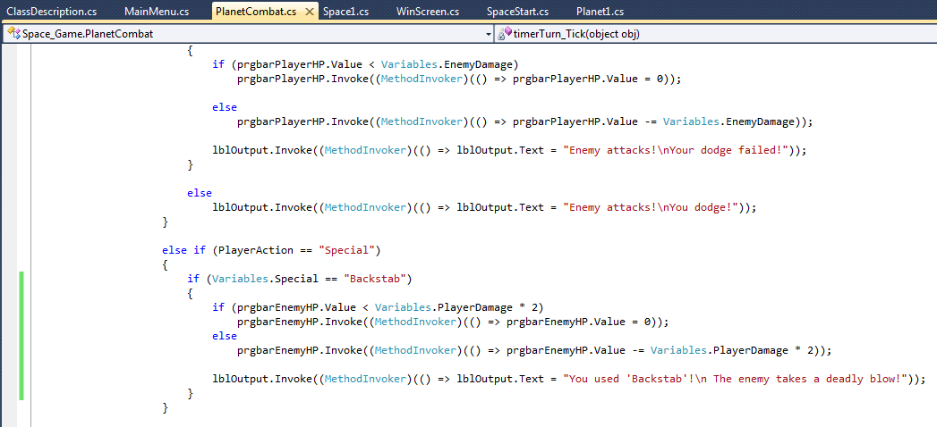Special skill code
Reflection | As with when I started with planet combat coding, I also found adding in the different classes enjoyable. This meant I managed to get a fair amount done, as adding in the classes meant also adding in the different images to use for the sprite animations.
Actions | As I had already done the “barebones” of the character/class selection, adding in the different classes was relatively easy. As for the stats, I just stored those as global variables to use during planet combat.
Resource  Bibliography | en.wikipedia.org – Researching different games combat systems.

Week 10
Weekly Progress Report | For week 10 I finished the class selection screen and then decided to play test the game through, fixing any bugs I that I encountered, if I could. I also began adding in more music, replacing existing music with new tracks and moving some to a different “location” within the game. Added music to forms that previously didn't have them, such as he end screen and game over screen. Also fixed some issues on the end screen. I added in an option of restarting the game or exiting after the credits and made space bar skip the credits.  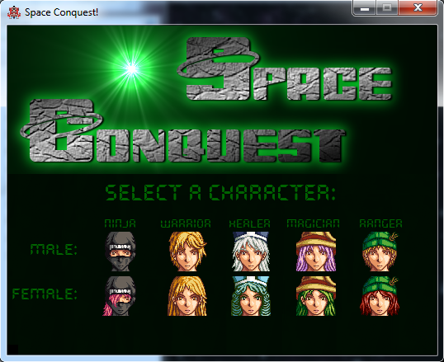Character selection screen  The monday of next week was also milestone presentation #2.
Reflection | As I found myself making nice progress, I decided to make the game more of a “game” by adding in more music and sound, while also play testing to fix any minor bugs or issues I had not encountered or had overlooked in favor of more important things.
Actions | For the new music, I returned to opengameart.org to search through for more tracks.
Resource  Bibliography | Opengameart.org – Assets (music, sound effects)

Week 11
Weekly Progress Report | For this week, I began coding the enemy movement on the planet and the asteroids in space. I also decided to try and improve the way player movement is coded on the planet. I also did some more minor bug fixing that I found during my play tests for player movement and enemy movement code.  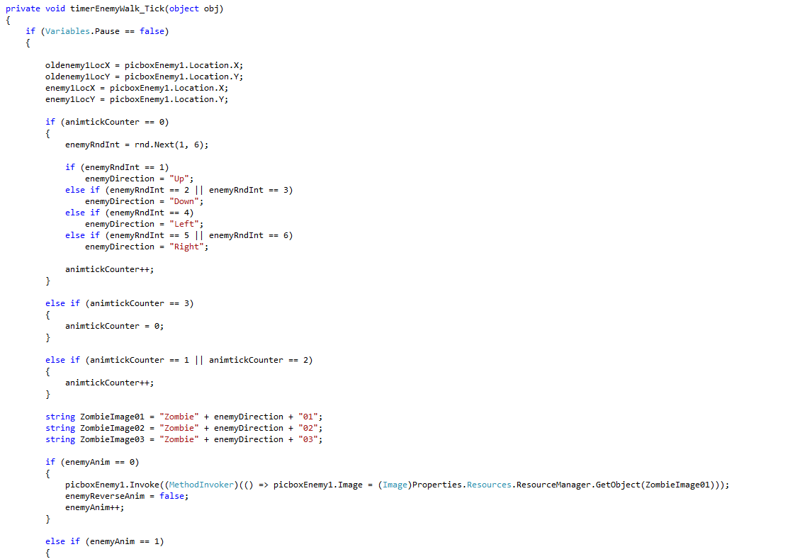Enemy movement/animation code
Reflection | As I didn't like the way player movement was working out I decided to try and code it differently in hope of improving it. This didn't work as well as I had intended but it was better. This improvement was taken from coding enemy movement, which also isn't as good as I'd hoped so far. For this reason, I postponed starting entirely on the asteroid movement. With more research I hope to improve both enemy movement and player movement.
Actions | Coding the enemy movement and player revised movement required some research online in order to make it better than what I originally did for player movement, while also adapting it from player movement to a random enemy movement.
Resource  Bibliography | msdn.microsoft.com – Visual Studio and C# tutorials and information  stackoverflow.com – Visual Studio and C# “tutorials” (Q and A site for programming)

Week 12
Weekly Progress Report | To start the week off, I worked on coding enemy movement on the planet form. After finishing that, I began to work on enemy/asteroid movement on the space form. With these two managing to work out well from a coding side of things, I began to consider going back and changing player movement. Since I now had working movement for enemies on the planet, I added in their sprites instead of just place-holder colors.  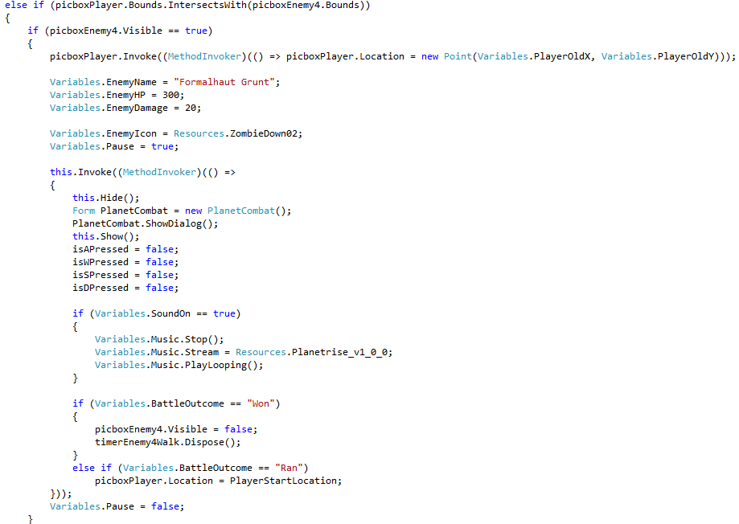Code for planet enemy movement
Reflection | After researching more on ways to code picture box movement, I f found a better way of doing things which meant that I could go back to the code for player movement and make it work better. However, the reason I may not do this is because of the way enemy movement works. Since the movement isn't determined by the player, just by random, it's all done through a timer. In order to change the planet movement I would have to recode the majority of code for movement to be done through the sprite animation timer as opposed to during the keypress.
Actions | Since I was hoping to find a better way of coding movement, I researched on sites such as stackoverflow.com and msdn.microsoft.com. I also revisted opengameart.org again to find more assets to use for enemy sprites. After finding some, I used GIMP to edit them for use.
Resource  Bibliography | msdn.microsoft.com – Visual Studio and C# tutorials and information  stackoverflow.com – Visual Studio and C# “tutorials” (Q and A site for programming)  opengameart.org - Assets (sprites)

Week 13
Weekly Progress Report | For week 13 I started by finishing the revised player movement code. I then began designing proper levels with objects that are either impassable or can cause death. I also worked on coding space asteroid movement.  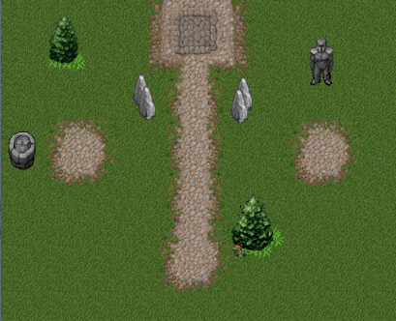Level 1 map
Reflection | As I am soon to enter the final two weeks of my project I think I really need to pick up the pace. While I may have started the project with a brisk pace, it has slowed recently due to other commitments giving me less time to work on the project. As there are still issues I need to address (planet combat), I may have to change my plans for the space segment as I may not have time to do the stealth gameplay that I had decided on as an alternative. Since I really want to try and get some part of the game looking good, I decided to work on making the planet levels at least looking better than a repeating pattern. Hopefully I will managed to at least get the planet sections looking good and the planet combat working decently.
Actions | For the level designs, I used GIMP to edit assets I had previously got from opengameart.org.
Resource
Bibliography

Week 14
Weekly Progress Report | In my final week I wrapped up the level designs, completely added functionality to them. For planet combat, I managed to fix the major issue I was having with it not firing correctly all the time, and I added in limitations/restrictions to the special moves. I also tried to balance out the stats in general. As I neared the end of the week I began to design the level map and add in functionality for the final planet, meaning I was almost ready for publishing. All that required was play-testing after. However, during the final few days, the program became corrupt and I lost a lot of code. Due to the way the corruption affected my code, I managed to reconstruct most, if not all, of the program.  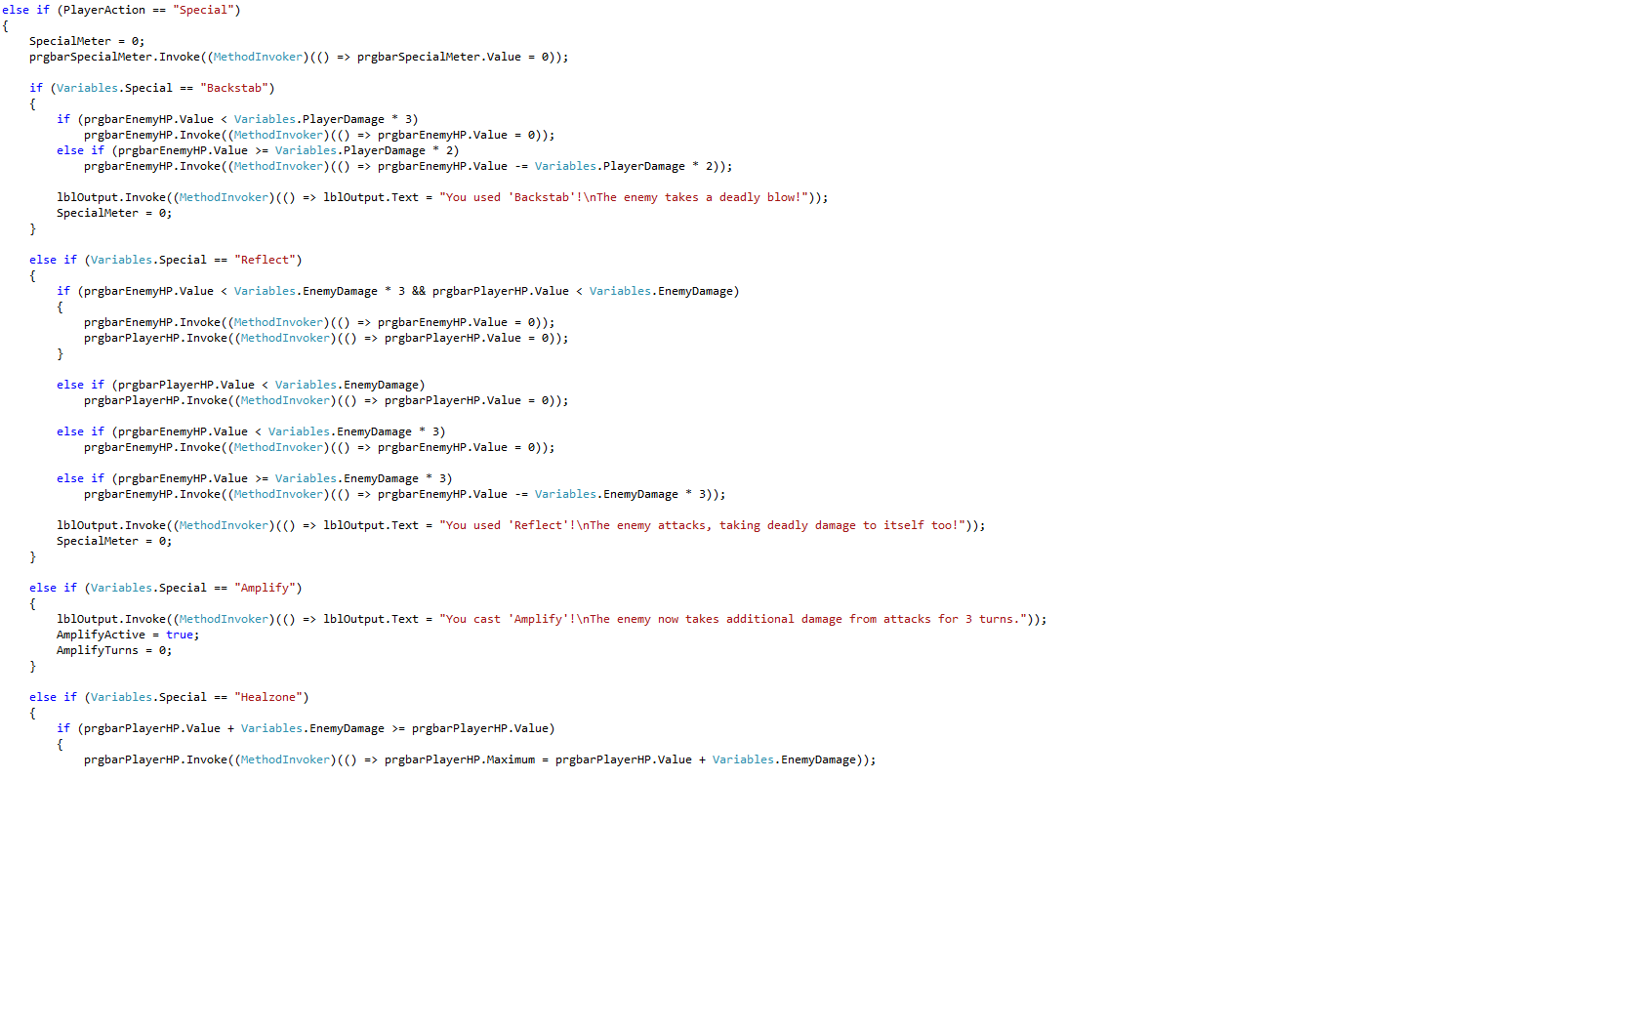Some coding for special moves with limitations
Reflection | With plenty of additions and fixes occurring during this week, it put me back on track to complete the game on time. However, because of the set back with my code corrupting, I may not be able to finalise the project as well as I would like.
Actions | I continued using GIMP to create the level maps. When my code corrupted, I managed to open up the .cs files located inside my project folder and copy certain parts of coding across, that wasn't corrupted, and use that to rebuild.
Resource
Bibliography

